**Running PR-OWL 2 RL plug-in using GraphDB Lite**

1. You should get a copy of GraphDB Lite. It is free, but you will have to fill the form and download the software from site http://ontotext.com/. This tutorial was developed using version **7.1.0**.
2. Unzip the file and run the **graphdb** script in the bin directory. You will find more informations in README file on graphdb directory.
3. Open your browser and access graphdb workbench in <http://localhost:7200>.

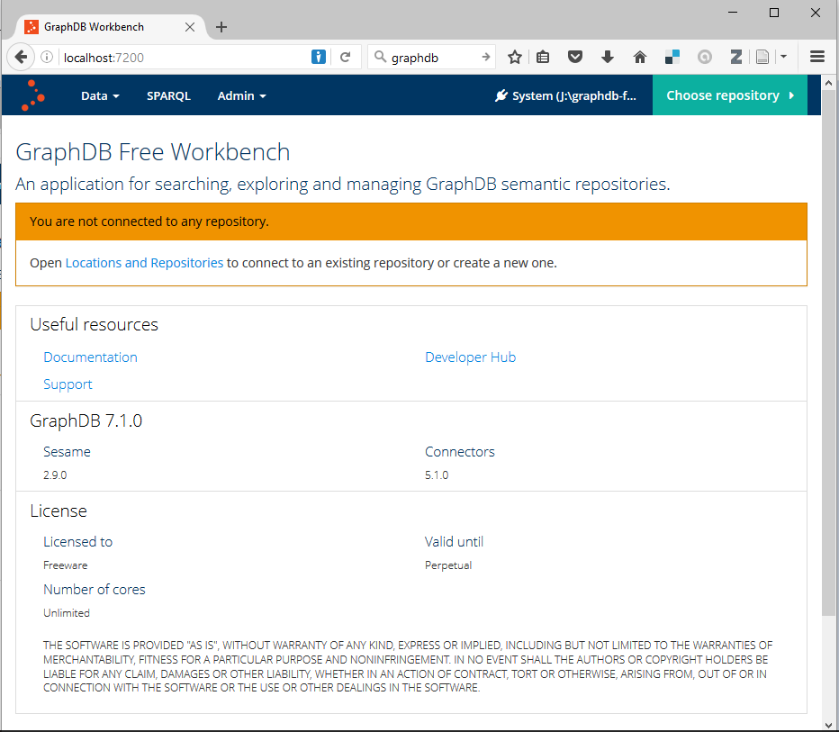

1. Create a new repository in GraphDB workbench.
   1. Admin
   2. Locations and Repositories
   3. Create Repository
   4. Choice a Repository ID. The rule-set should be OWL 2 RL

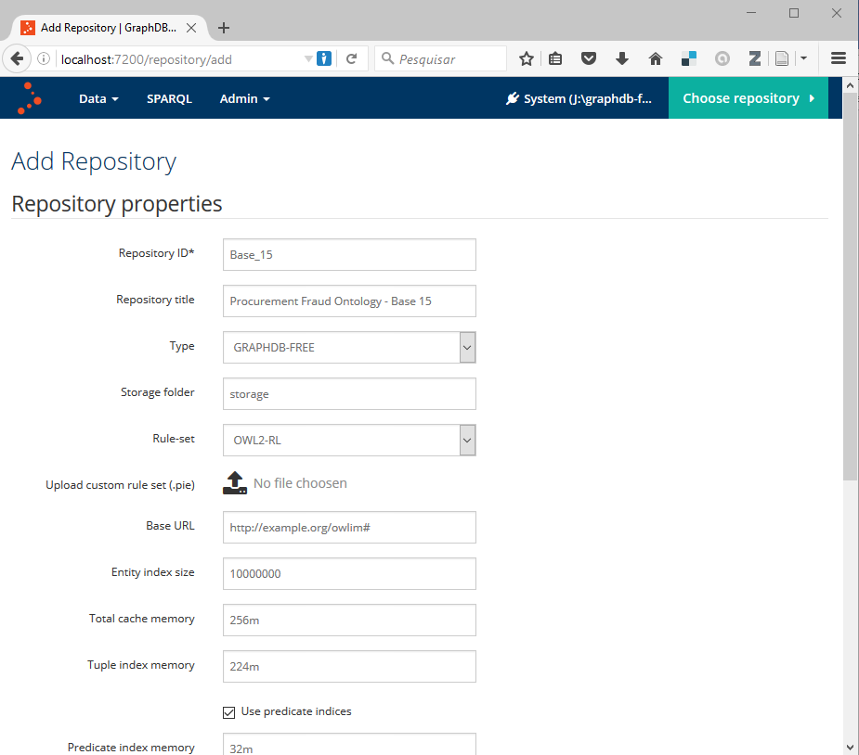

1. Connect to repository.
2. Load the ontology files and assertive base:
   1. Acess Data -> Import
   2. In Local Files, select and load the following files:
      1. pr-owl2rl.owl (available in unbbayes-4.21.18\plugins\unbbayes.gui.mebn.prowl2rl-1.0.0\pr-owl)
      2. procurementfraud.owl (available in unbbayes-4.21.18\plugins\unbbayes.gui.mebn.prowl2rl-1.0.0\examples)
      3. base15.ttl (available in unbbayes-4.21.18\plugins\unbbayes.gui.mebn.prowl2rl-1.0.0\examples)
3. Execute UnBBayes and load procurementfraud.ubf file using OWL 2 RL option.
   1. In the first time that you use the plug-in Protégé will show a box asking for the localization of pr-owl2-rl. This occurs because the ontology still don’t is in the web address. The ontology is in the directory: plugins\unbbayes.gui.mebn.prowl2rl-1.0.0\pr-owl.

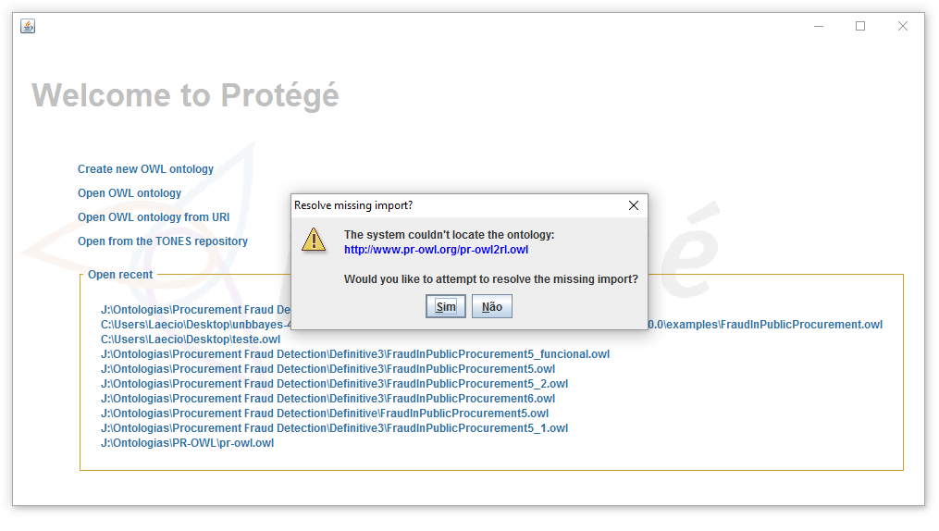

1. Click on Configuration Button.

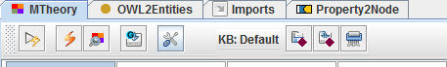

1. In Knowledge Base panel, select “Triplestore Reasoner” option and fill the form with connection details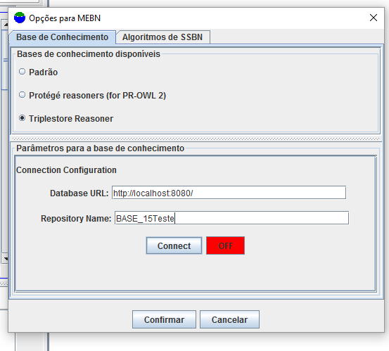
2. At SSBN algorithm panel, select Bayes-Ball algorithm.

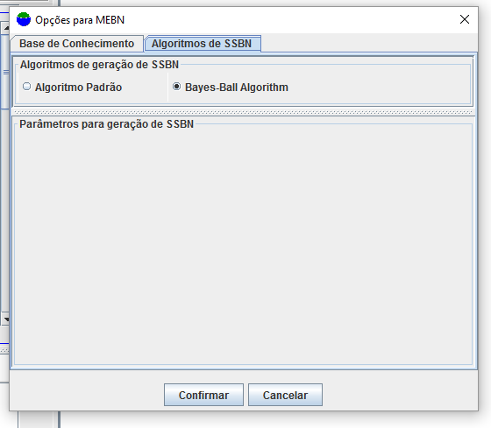

1. OK. Now you can execute queries.

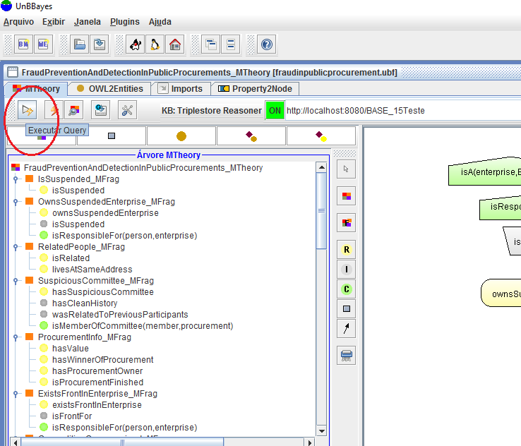

1. Select the query arguments. This should be done using the complete URI of the entities, like:

<http://www.pr-owl.org/examples/pr-owl2/ProcurementFraud/ProcurementFraud.owl#procurement0>

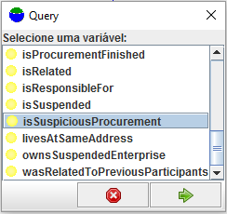

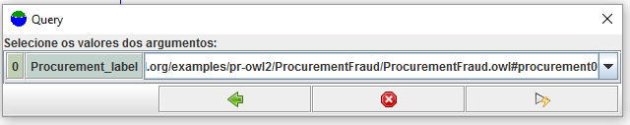

1. UnBBayes execute the query generating a SSBN.

